**CIS-350  
Infrastructure Technologies**

**Individual Lab 1 Report**

**Student Name**: **______Thomas Limbu________________________**

**Worth 50 points Due Date: See Blackboard**

**You must use this template to hand in Individual Lab1 Report.**

1. Insert the *Lab1_Tree* file from p. 25 of the Lab1 instructions into the space provided or use the *Alt-PrtScr* keys to capture the full screen output (full window) from command *TYPE Lab1_Tree* on p. 25 and paste that window here. (20 points)

1. Below you have the following directory structure. At the top there is the root directory denoted by a backslash "\". *CLASSES*, *DOS*, *WINDOWS*, *BOOK*, *FINANCE*, etc. are the names of subdirectories residing under the root directory; *CONFIG.SYS* is the name of a file residing in the root directory, and *chkdsk.exe*, *CHAPTER1.DOC*, *Q.EXE*, etc. are the names of the files stored in the subdirectories. The system prompt displays"*C:****\****>*" which means that the current/default drive is *C* and the current/default directory is the root directory "**\**". The root directory "**\**" is just the origin for other directories/subdirectories. (30 points.)

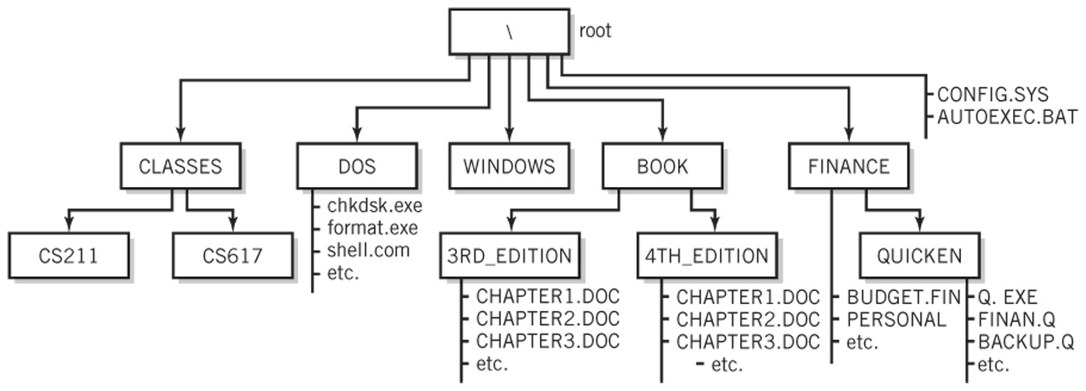

All questions 2.a through 2.j. are based on the above directory diagram. For questions 2.a through 2.e assume the prompt "*C:\>*" is displayed.

1. Write a command to copy file *CONFIG.SYS* to directory *WINDOWS*. The copied file should have the same name as the original file, i.e., *CONFIG.SYS*.

_____________C:\>copy \config.sys\windows_____________________________

1. Write a command to copy file *CONFIG.SYS* to directory *CIS211*. The copied file should have new name *CONFIG3.SYS*.

________________ C:\>copy \config.sys\Cis211\config3.sys____________________

1. Write a single command to copy all files whose names start with letter *C* from directory *3RD_EDITION* to directory *CLASSES*. Use the wildcard(s) *

___________________ C:\>copy \3rd_Edition\c*\Classes _______

1. Write a single command to erase from directory *3RD_EDITION* all files whose file extension is DOC.

____________ C:\>erase \3rd_Edition\*.doc__________________________

1. How many files would be erased by the command from point d above? ____3______
2. Look at the diagram. Assume that prompt "*C:\FINANCE>*" is displayed, meaning that the current/default drive is *C* and the current/default directory is *\FINANCE*. Write two separate *SORT* commands. Each of the two commands would accept input from file *PERSONAL*. However, the first command would route the output to file *PERSONAL1*, and the second one would append the output to file *PERSONAL2*.

_____________sort </personal>personal1___________

_sort</personal>personal2________________

1. You are still in directory \FINANCE. Assume that *PERSONAL* is a large file. What command that uses a piping operation would you use to display the contents of the file one screen at a time (to prevent the output from scrolling off the screen)?

_____C:\>dir \Finance\personal_

1. Look at the diagram. Assume that prompt "*C:\FINANCE>*" is displayed. Write the command which would change the current directory to the root directory. ______

_ cd..__

1. Look at the diagram. Assume that prompt "*C:\BOOK>*" is displayed. In the space provided, sketch the directory structure with the subdirectory and file names which would command *TREE* /F generate.

3rd_Edition

Chapter1.Doc

Chapter2.Doc

Chapter3.Doc

Etc.

4th_Edition

Chapter1.Doc

Chapter2.Doc

Chapter3.Doc

Etc.

1. Now assume that the "C:\ " prompt is displayed. Using a piping operation | and then the output redirection >, write a single command that would pass the output from the DIR command as an input to the SORT command and the output from the SORT command would be directed to a file named *Sorted_Directory.*

______ dir | sort > Sorted_Directory________________________

1. Optional. Briefly describe any issues with the commands which did not work. Point me to the specific pages and suggest changes. Thanks.